Rohan Kulkarni
A023 45207210002
Prim’s Algorithm
Mini Project

- What is Prim’s Algorithm?

- In Computer Science Prims Algorithm is a greedy Algorithm that finds a minimum spanning tree for a weighted undirected graph.
- It means that it find the subset of the edges that forms a tree that
Includes every vertex, where the total weight of all the edges in the tree is minimized.

- Applications of Prims Algorithm

- In real-daily-life it can be used to design a network linking small outlying villages.
- A network of pipes for drinking water or natural gas ,an electrical grid, irrigation channels, a fibre-optic, placing microwave towers etc.
- Designing Local Area Networks (LAN’s)
- Making electrical wire connections on a road panel
- Constructing highway roads or rail roads spanning over several cities.

- Prim’s Algorithm Pseudocode –

- T = Φ;
- U = {1};
- While (U≠V)
Let (u , v) be the lowest cost edge such that u ∈ U and v ∈ V - U;
T = T ∪ {(u , v)}
U = U ∪ {v}

- Example of a Code :

#include <cstring>
#include <iostream>
using namespace std;

#define INF 9999999

// number of vertices in grapj
#define V 5

// create a 2d array of size 5x5
//for adjacency matrix to represent graph

int G[V][V] = {
{0, 9, 75, 0, 0},
{9, 0, 95, 19, 42},
{75, 95, 0, 51, 66},
{0, 19, 51, 0, 31},
{0, 42, 66, 31, 0}};

int main() {
int no_edge; // number of edge

// create a array to track selected vertex
// selected will become true otherwise false
int selected[V];

// set selected false initially
memset(selected, false, sizeof(selected));

// set number of edge to 0
no_edge = 0;

// the number of egde in minimum spanning tree will be
// always less than (V -1), where V is number of vertices in
//graph

// choose 0th vertex and make it true
selected[0] = true;

int x; // row number
int y; // col number

// print for edge and weight
cout << "Edge"
<< " : "
<< "Weight";
cout << endl;
while (no_edge < V - 1) {
//For every vertex in the set S, find the all adjacent vertices
// , calculate the distance from the vertex selected at step 1.
// if the vertex is already in the set S, discard it otherwise
//choose another vertex nearest to selected vertex at step 1.

int min = INF;
x = 0;
y = 0;

for (int i = 0; i < V; i++) {
if (selected[i]) {
for (int j = 0; j < V; j++) {
if (!selected[j] && G[i][j]) { // not in selected and there is an edge
if (min > G[i][j]) {
min = G[i][j];
x = i;
y = j;
}
}
}
}
}
cout << x << " - " << y << " : " << G[x][y];
cout << endl;
selected[y] = true;
no_edge++;
}

return 0;
}

OUTPUT:

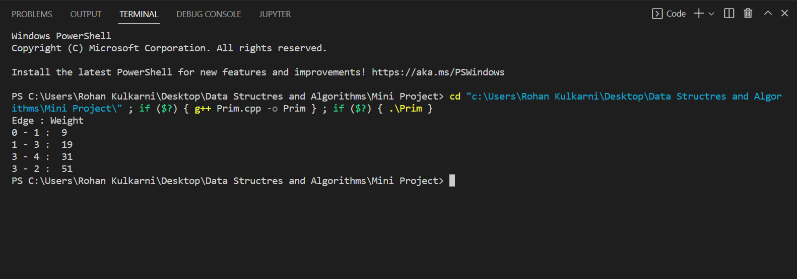

- Diagrammatic Representation of Prim’s Algorithm Along with solving an Example –

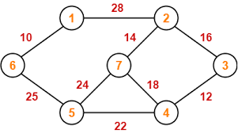

Example :

Step 1

Step 2
Step 3

Step 4

Step 5

